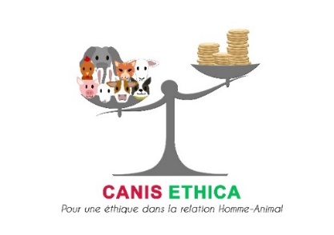
Press release
Saint Malo, September 4th 2018

Pets’ over-vaccination
Vaccination: a medical act not without dangers

No obligation
Camping, boarding, traveling, competition, prophylaxis, law, without vaccination it is not possible. Therefore, why an identical vaccine for Doggy and Kitty will be valid for 1 year in France but 3 years in the rest of Europe.
France is Europe» we hear every day. All European Citizen are equal in right. What about Directive 2004/28 / EC on the harmonization of veterinary protocols and medicinal products in the European Union?

Consumer right
In France, a single law on vaccination: the decree of 19 June 2018 on rabies vaccination of domestic animals. The problem, it gives all authority to pharmaceutical companies to decide the validity period of their vaccines on French soil. No matter the diseases, French with identical vaccines vaccinate once a year and other Europeans: once every 3 years.

Unfair trade
On April 11, 2018, the European Commission expressed its fierce determination to put an end to unfair trade practices in the European Union following the Dieselgate. It said it wanted to defend European consumers’ rights. However, it is about to reject the complaint lodged on 13 September 2017 by Canis Ethica, the French association for animals’ protection, which asks it to put an end to the unfair commercial practice on vaccines in France. Practice which benefits the pharmaceutical laboratories to the detriment of the French who see the health of their animals put at risk and their veterinary costs increase because they do vaccinate more often than in the rest of Europe.

Not without dangers
According to ANSES reports, French government agency controlling the National Agency for Veterinary Medicines, the number of cases of serious adverse reactions occurring in dogs and cats after vaccination, is increasing continuously by more than 40% per year. Serious adverse reactions cause suffering, illness, death. By revaccinating in France every year or every two years dogs and cats: their risks of developing serious adverse reactions leading to their deaths are increased tenfold.

First victory
On June 19, 2018, Canis Ethica, after 3 years of campaign, obtained a first modification of the decree on vaccination against rabies. Indeed, the obligation to revaccinate 1 year after the primary vaccination of puppies and kittens has just been removed. Therefore, if a puppy or kitten is vaccinated for the first time in his life with a vaccine that lasts 3 years for rabies, he can have his vaccine recall 3 years later and not 1 year later.
Now, it is a question of obtaining that the vaccines, all diseases combined, which are already valid 3 years in Europe are also automatically in France!

Mobilization
On August 30, 2018, Canis Ethica relaunched its complaint to the European Commission, created a bilingual video and petition to alert on the situation.
It asks the support of all associations of Consumers right, Health and Animals defense so that every time an animal vaccine is available in Europe with a duration of validity of 3 years, it is it in France, automatically under the same conditions.

Video via Facebook
Video via YouTube

Petition via Facebook
Petition via MesOpinions.com

Prospectus

Relaunch of complaint at the European Commission via Facebook
Letters to European Commission

Contacts for more information:
Mrs. Thilo HANE president-founder of Canis Ethica
Cellular: +33(0)6 7027 6352
Email: Thane@canisethica.org Website: www.canisethica.org
Facebook: www.facebook.com/CanisEthicaFrance Twitter: https://twitter.com/CanisEthica

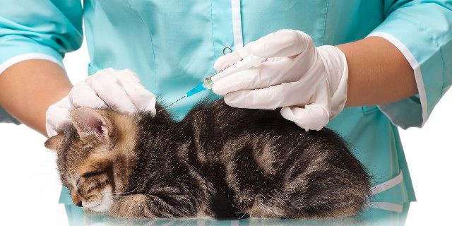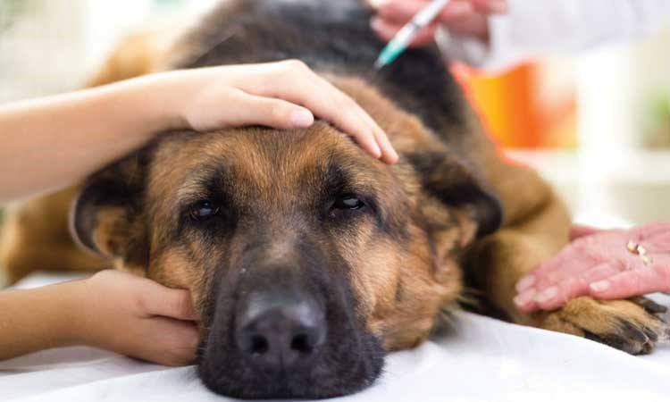

Additional Information. Extracts from the complaint filed with the Defender of Human Rights excluding press release from European Commission (EC):

- Press release EC of 11 April 2018 http://europa.eu/rapid/press-release_IP-18-3041_fr.htm

- According to Article R. 5146-41-5 of the Public Health Code "we mean by:
Serious Adverse reactions: An adverse reaction that causes death, is life threatening, causes permanent or prolonged symptoms, results in a birth defect or malformation, or causes significant disability or disability in treated animal.

- “90% of pharmacovigilance declarations sent to institutional actors are sent by veterinary practitioners: with 83.9% of these pharmacovigilance declarations concerning dogs and cats. [...] These figures reflect a much greater exposure of different animal populations to certain types of products and / or higher responsiveness of registrants in comparison to effects on healthy animals.
The distribution of veterinary pharmacovigilance reports between cases of serious and non-serious adverse reactions varies according to the therapeutic class concerned: for vaccines, 71% of the reports transmitted for the dog and for the cat concern cases of serious adverse reactions. Several cases of anaphylactic reactions resulted in the death of the animals. ”

- The number of pharmacovigilance reports sent directly to ANSES-ANMV increases by more than 40% every year, underlining the national under-reporting of adverse effects in animals. This increase concerns both serious and non-serious cases. +43.9% of severe case reports in 2013; +44.9% of serious case reports in 2014; +47.4% of serious case reports in 2015

- 52% of French people with a pet adopted him/her to receive affection; 50.7% of French people with a pet are attached to it as to a child; 11% of French people with a pet adopted it to fill the loneliness.

- "The reaction to the loss of a pet is comparable to that which follows the loss of a human being with the psychological, emotional and, sometimes, metaphysical shock felt by humans when their pet dies."

- "Pet market in France, weighs 4.2 billion euros a year. A craze related to a French population who sees the animal as a full member of the family that must be cared for and offered the best. "

- France has 20 million dogs and cats for 66 million people. 98% of whom vaccinate their pets and face veterinary expenses accounting for 19% of the budget they devote to their pets. It is a 72% increase in the budget spent on veterinary fees in 15 years

- The European veterinary drug market represents a turnover of 4.3 billion euros. France being the largest European market with 24% of the European Union market. There is a French tradition of veterinary medicine since Pasteurian rabies vaccines.

ANSES 2015 report _ Veterinary Pharmacovigilance, P.5, 20-23 https://www.anses.fr/fr/system/files/ANMV-Ra-Parmacovigilance2014.pdf
ANSES 2015 report_ Veterinary Pharmacovigilance, P.19 https://www.anses.fr/fr/system/files/ANMV-Ra-Parmacovigilance2014.pdf
P.40, ANSES, 2015 Annual report, Post marketing authorization, veterinary drugs surveillance, October 2016
FACCO/TNS SOFRES Survey, March 2015
Gagnon, 2006
C.Gorrab interview, financial analyst at Euromonitor International, Les Echos, June 2015.
Pets’ hygiene and cares represent a 580 million annual budget in France, Les Echos, June 2015
SantéVet, Typical profile of pets’ owners subscribing to an insurance for their animal

